40.39: a) The transition energy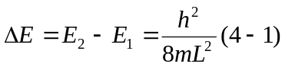
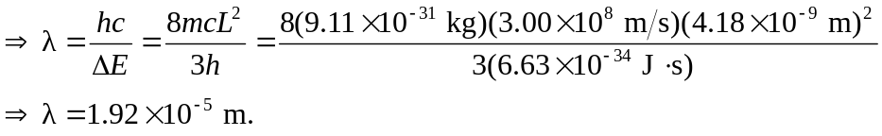
b) 